How can we improve the performance of a neural network
To speed up training of neural network we do weight initialization, batch normalization and activation function.
Optimizer also play role in speed of neural network speed

Types of Optimizers
My dataset has 500
I am doing 10 epochs
Batch Gradien Descent: ismy 10 dafa weights update hon gy or 1 epoch mn saray data pr lagay ga
Stochastic gradient Descent: ismy 5000 dafa weights update hon gy, ye hr epoch mn 500 dafa weight update karay by taking one data point only
Minibatch: mera batch 100 data points ka hai, 5 dafa hr epoch mn weights update hon gy, total 50 martaba weights update hon gy.

Challenges for gradient descent:
1.Learning rate:
Right value of learning rate is crucial for convergence of neural network
Update formula (new_weight)= old_weight – learning rate * dL/dw
2. Learning rate scheduling:
Ismy mn predefine krty hain ky learning rate itny epochs bd aisay change ho ga
3. Seprate Learning Rate:
Ham do weights ky liye separate learning rate nhi rakh skty ky aik tezi sy change ho likin dsra slow change ho
4. Local Minima:
Multiple minimas, global minima mn phnchna hai likin local minima mn phas jaty hain.
5. Saddle point:
Saddle point aisa point jahan hr taraf same hi chz ho Aisi jagah jo minimum ki trhan behave karay likin asal minima ki taraf na jaye

Exponentially Weighted Moving Average:
It is used in:
- Timeseries Forecasting
- Financial
- Signal Processing
- Deep Learning Optimizer

Jo data point bad mn aye ga, suppose data point 1 and data point 5, data point 5 bad mn ayah ai to isko zyada weightage mily ga, isi trhan data point 7 data point 5 ky bd mn ayah ai to isy zyada weightage mily ga .
Mathematical Formula:
Vt = BVt-1 + (1-B)0t
Vt = Exponential moving Average at point t
BVt-1 = B is a constant and it’s value range from 0-1, Vt-1 is exponential moving average of previous point
(1-B)0t = theta t is the value at that point for which we are calculation moving average

NOTE:
At first point, Vt or exponential moving average is considered zero or the same value at first point. Later gives more accurate results

Dummy Data:
Dates | Temperature|
D1 | 25 |
D2 | 13
D3 | 17
D4 | 31
D5 | 43

Ab exponential moving average at a particular point is the average of how many previous days?
Mtlb ky aik point pr jo hame EWMA nikal rhy hain wo pichly kitny dino ki average hai?
Formula for calculating days:
No. of days = 1 / (1-B)
Farz karo hamara beta B 0.9 hai.
No. of days = 1 / (1-0.9) = 1/0.1 = 10 days
Agar beta ki value 0.9 hai to at a point EWMA pichly 10 points or dino ka average hai us point pr

Jitna beta ka value zyada ho ga utna puranay waly points ko value zyada mily ga. Beta decides ky past points ko kini weightage dy rhy ho.
Jab ham beta ko kam krty hain, kyn ky ham current points ko zyada wright dety hain

0.9 beta ka value sweet spot hai jo deep learning mn use hota hai.

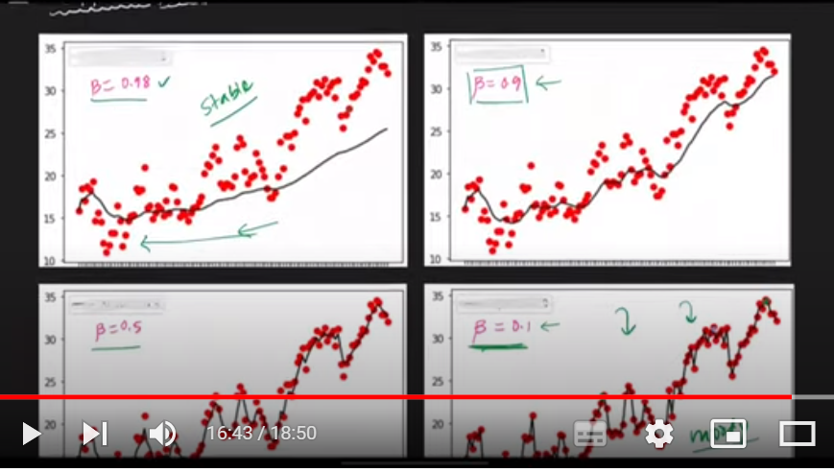
Jitna beta ka value chota hota ja rha hai grapgh moody hota ja rha hai.

Code:
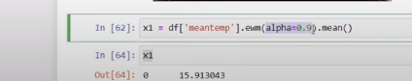
Alpha = 1- Beta
AND
Beta = 1- alpha
Code mn alpha 0.9 hai, to beta 0.1

Optimizers
SGD with momentum:
Contour plot is a way to visualize 3d graphs on 2d. Colors represent intensity of altitude matlab, info of 3d save as 2d.
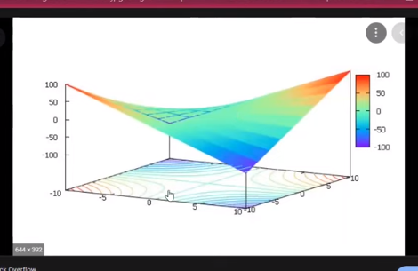
Oper walay grapgh mn blue points walay concentric circles lower altitude ko show kr rhy haiin, or orange concentric circles higher altitude ko, so 3d ki info 2d mn save hai.Jahan py saddle point ho wahan pr concentric circles contour plot m naik dsry sy dur hoty hain, kyn ky hr point ka altitude same hai. Darmayan mn plot ky surface flat hai mtlb no change of altitude, 2d pr uska project mn concentric circles nhi hain.
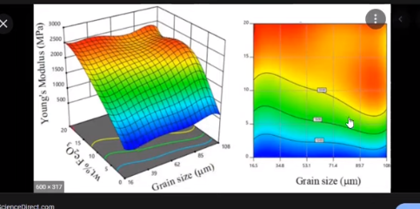

Convex Vs Non-Convex Optimization
Covex is simple loss function curve
Non-conves is complex loss function curve
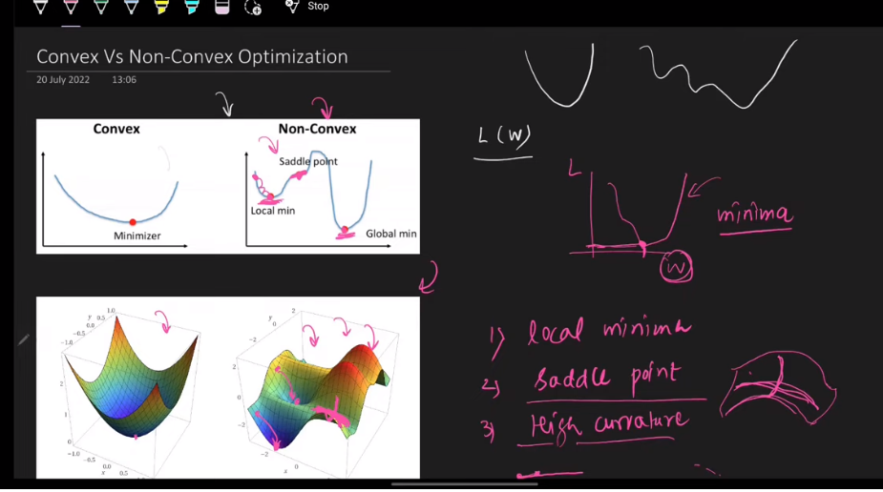
Non-convex optimization probelems:
- Local minima
- Saddle point (slope changes slowly making training slow)
- High curvature

Momentum Optimization.
In neural networks we mostly have non-convex optimization problem
Problems with non-complex optimization are :
- High curvature
- Consistent gradient
- Noisy gradient (local minima)
Momentum optimization oper walay 3no problems ko navigate krti hain, jahan slope mn change kam ho wahan pr fast training, local minima sy nikal skti hai

Momentum optimization Core intuition:
Agar hamary pichly gradients hamein aik hi direction mn move krwa rahein hain to ab confident ho ky usi direction mn fast move krny lagty hain.
Or physics example agar ball aik hi direction mn move kr rhi hai oper sy nichy to jaisay jaosay wo nichy ati jaye gi or zyada momentum pakarti jaye gi

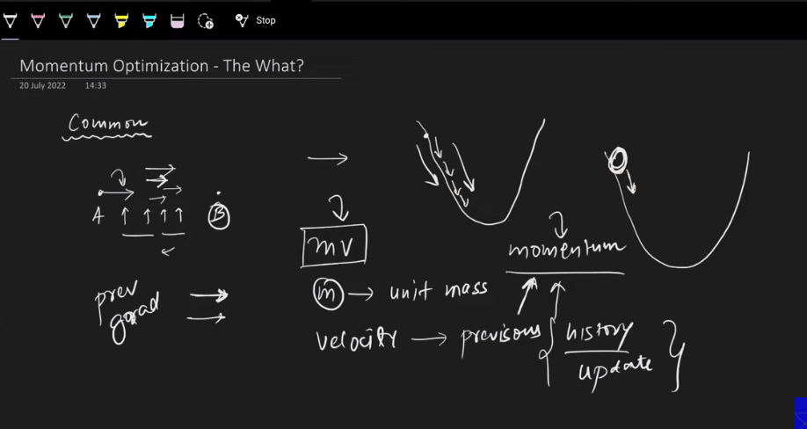

BENEFIT OF USIN MOMENTUM SGD OPTIMIZATIO IS FAST TRAINING AS COMPARE TO NORMAL SGD

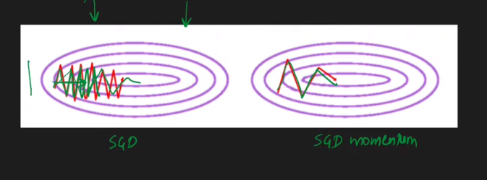

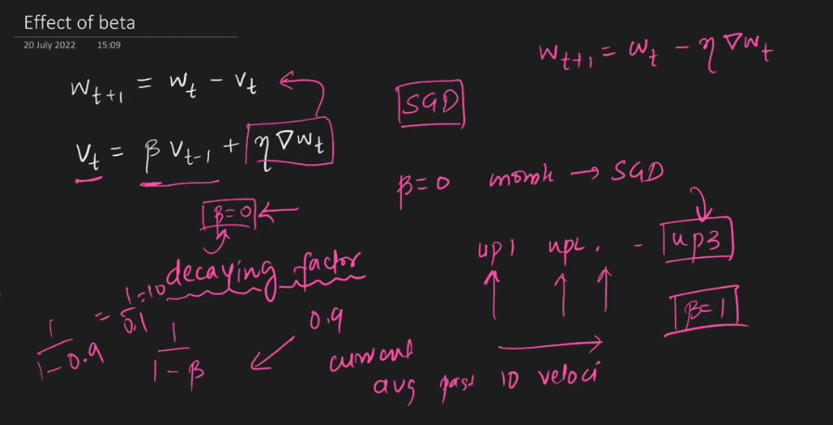
Update weight rule wt+1 naya weight
Wt purana weight, Vt velocity term
Beta = 0, normal SGD
Beta = 1, No decay, dynamic equilibrium
Advantage of Momentum:
- Escapes local minima
- Faster Training.
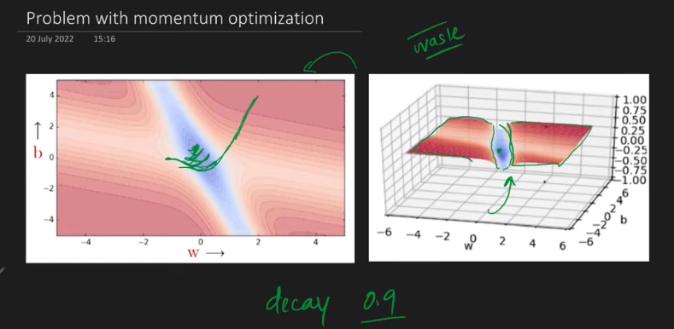
Momentum optimization is faster but not very fast as compare to othe roptimizers

